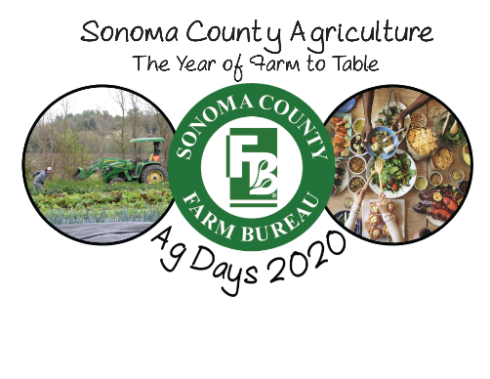
Sonoma County Farm Bureau Recipe Contest

Description of Contest:
Create a recipe utilizing Sonoma County homegrown products, take a photo of the prepared recipe AND include an explanation of “What Makes the Recipe Healthy”. One entry per class, student or group of students.

What to Consider in Judging the Recipe Project:
- Requirements:
  - Does the project have a recipe?
  - Does the project explain what makes the recipe health?
  - Does the project have picture(s) of the prepared recipe?
  - Does the project include ingredients that are actually grown in Sonoma County?
- Recipe:
  - Does the recipe list all of the ingredients needed to make the snack?
  - Does the recipe have unhealthy ingredients, like processed ingredients, i.e., cookie? (if so, maybe the snack does not qualify for the competition?)
  - Does the recipe list the quantities needed for each ingredient? (teaspoon, ½ cup, etc.)
  - Does the project provide directions re: how to prepare the ingredients to create the snack?
  - Are the directions easy to follow? Will you be able to make the snack?
- Analysis:
  - Is the explanation of how/why the recipe is healthy make sense?
  - Is the explanation factually accurate?
  - Is the explanation convincing? Do you believe it?
- Professionalism:
  - are there spelling mistakes, grammar mistakes?
  - Is the paper clean (is it crumbled? Dirty looking?)
  - Is the hand-writing neat?
  - Is the project typed?

- Aesthetics:
  - Does the project look nice?
  - Is it pretty?
  - Has there been an effort to make it look artful?
  - Are there stickers, different colors used? Glitter?
  - Does the picture(s) of the prepared recipe add to the quality of the project? Do the pictures make the project look too cluttered?

